MEETING NOTES
LYV-GWMA Implementation
Thursday, September 16, 2021
1:00 PM to 3:00 PM
*notes and any Q&A taken from meeting are in blue font

- Welcome/Introductions
Damon Roberts has replaced David Bowen as the new Section Manager for the Water Quality Program at the Department of Ecology, Central Regional Office.

- Lead Entity (S. Yakima Conservation District)
Key Point - Deep soil sampling has not happened yet. Funding for equipment was obtained from Commerce, additional funding was pulled because of Covid 19 Pandemic

Roundtable:
Dave Hawes – Continuing work on getting minor things resolved, such as instances where individuals putting irrigation pipe over wells. Preliminary work on educational outreach. Dave provided this link in chat: https://www.yakimacounty.us/541/Groundwater-Management
Question Posed – What about the GIS and database that was started – will this be maintained as well? Answer from Dave Hawes – Yes.

Shawn Magee – COVID19 has definitely had an impact on work. Their group has been looking into nitrate systems/testing, funding, etc. for that. Researching through state wastewater or other alternatives that can lead to overall reduction in nitrates. Possibility of bringing on a full time technician to solely focus on sampling of monitor wells.

Gary Bahr – Coordinating support/informational meetings with the dairies. Process of dealing with winter mortality concerns and how to deal with supply chain issues due to COVID. Working on mortality composting education videos. Links shared in chat: https://farmersnetwork.wsu.edu/extension-education/webinars/2020/
https://eorganic.org/node/34204

Melanie Redding – Ambient Groundwater Monitoring Network (pacific ground working group) sampling kicked off. Sampling for Nitrates. Team knocked on a lot of doors over the summer. Lots of excitement around this project. Sampling regularly for the first 2 years, then plan to do annual after. Overall goal is to determine if ground water is getting better/worse and conduct lots of educational outreach. Two staff members have been solely working on this project/conducting sampling – they recently took their last samples. Excited about this accomplishment. Originally 30 monitoring wells (see attached screen shot of map)
Working on finding a way to post the data summaries (minus personal info) online where the public and agencies can view this information to see how the aquifer is doing over time.
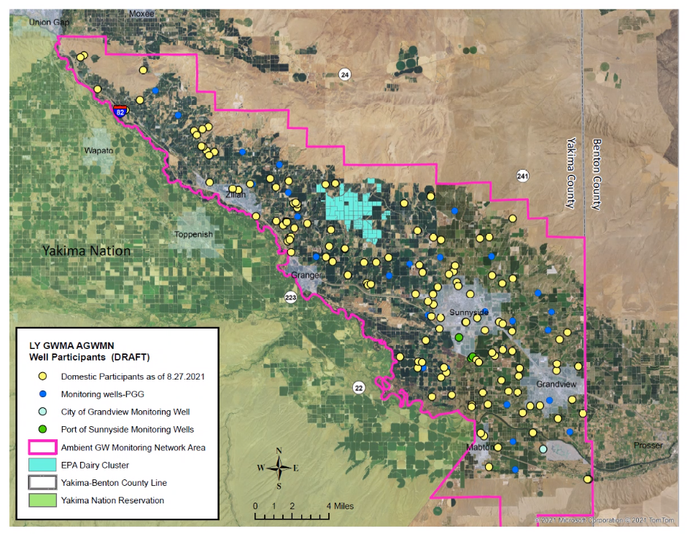

Sage Park – Exploring funding options for providing safe drinking water for everyone living in the GWMA – due to COVID19, this has slowed this process. Looked to the DOH to see what they may be able to do. They were at capacity. Wondering if this is something we can begin looking into and working on again. Figure out a way to provide some clean drinking water to people down there. Shawn and Ryan will follow up and look into what the next step will be. Sage will forward the email from DOH to the group/GWMA committee.

- Where are we with prioritized recommendations? Updates from the group.
  - SYCD
  - Roza-Sunnyside Joint Board
  - Yakima Dairy Federation
  - Yakima County Farm Bureau
  - Yakima County
  - Yakima County Health District
  - Washington Department of Health
  - Washington Department of Agriculture
  - Ecology

- Funding (Group Discussion)
Legislative update – end of October. Rodney agreed to take the lead to discuss budget needs on this. Anyone that is looking at needing funding are encouraged to attend. Sage had a meeting w/representative(s) – there will be six reps and senators and commissioner Lindy to attend a meeting to provide an update on what has been done and what the funding needs may be. Participation is highly encouraged. Date to be announced.

Question Posed - Has a GWMA funding package ever been proposed to legislature?
Answer from Gary Bahr – Yes, there were a series of meetings that occurred. A supplemental package was put together. This is what eventually led to Melanie’s project. Right now we are well positioned to take this up again. Certainly, there is more we can do and will use the meeting in October to bring this up again.

Damon asked the group – What was talked about regarding reporting/summarizing? – importance of capturing what is being done.
Everyone agrees that having something that captures what the group is working on so that there is something that can be shared would be beneficial to keeping all in the loop.

Gary Bahr shared the following link: https://agr.wa.gov/departments/land-and-water/natural-resources/soil-health

NEXT MEETING PLAN -
Question Posed to group - What do we want to do – moving forward with having GWMA implementation committee meetings?
Sage: Monthly check-ins suggested.
Damon: We may throw out a doodle poll monthly to see what works for everyone.

Group agreed that Thursday afternoons work the best – Aiming for OCT 7 for next virtual meeting and hoping to have possible meeting in person for following month.

- Moving Forward (Refer to WAC 173-100-100 below)
  - Detailed Implementation Schedule (Certification Plan)
  - Water Supply Alternatives (Certification Plan)
  - Effectiveness Monitoring (b)
  - Adaptive Management Plan (c)

- Legislative Update (October)

- Other Good of the Order

For Reference WAC 173-100-100
(6) An implementation section comprised of:
(a) A detailed work plan for implementing each aspect of the
groundwater management strategies as presented in the recommendations
section. For each recommended management action, the parties responsible for initiating the action and a schedule for implementation shall
be identified. Where possible, the implementation plan should include
specifically, worded statements such as model ordinances, recommended
governmental policy statements, interagency agreements, proposed legislative changes, and proposed amendments to local comprehensive
plans, coordinated water system plans, basin management programs, and
others as appropriate;
Certified on 10/25/2019 WAC 173-100-100 Page 2
(b) A monitoring system for evaluating the effectiveness of the
program;
(c) A process for the periodic review and revision of the groundwater management program.

